Broomhall, Greg
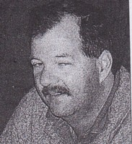
Graduated from forest cadet course 1976. Worked for Forests Department in 1970s. Forester at Jarrahdale transferred to Albany in 1988.

